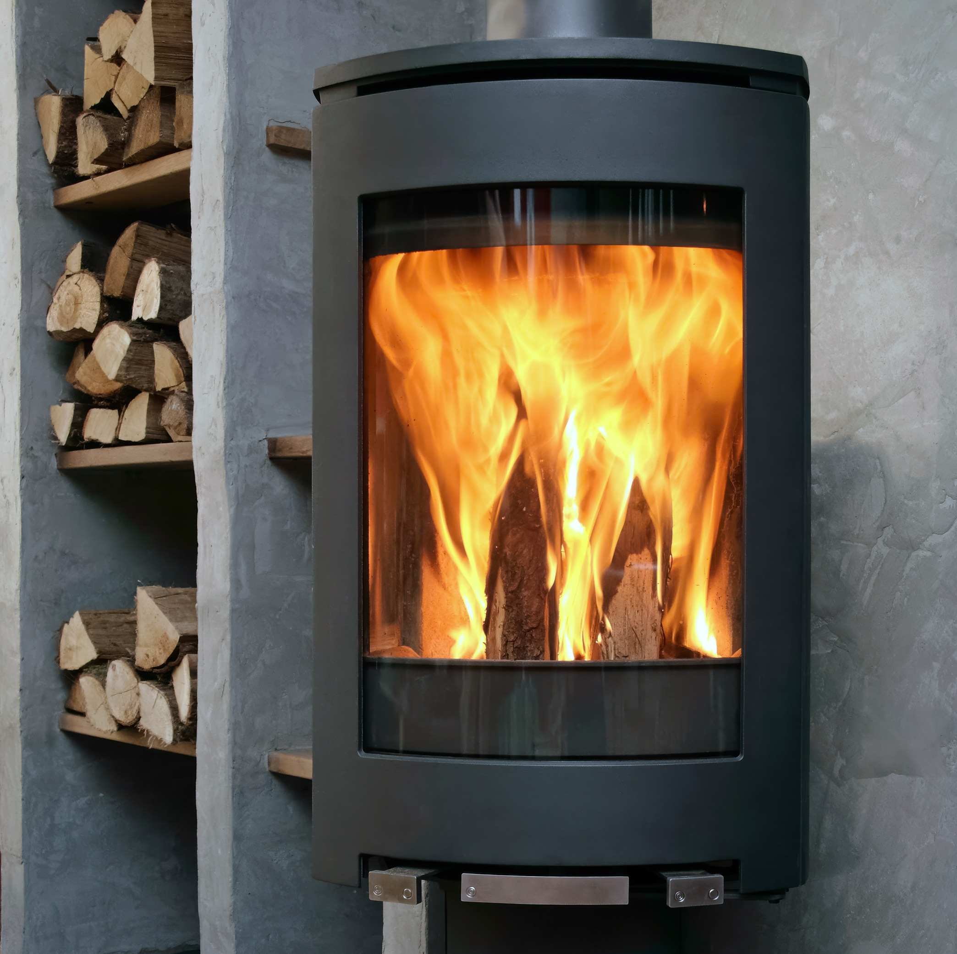

Working Together to Improve Air Quality:

Guidance for Municipalities

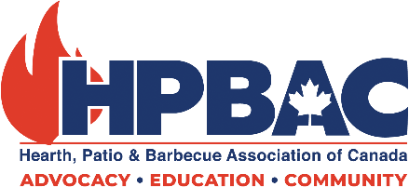

Hearth, Patio & Barbecue Association of Canada 2026

Contents

Executive Summary | …3
Solid Fuel Heating in Canada: An Introduction | …4
Practical Policy Options for Air Quality Improvement  - Three-Pillar Plan  - Addressing Local Issues | …6
Incentivizing Appliance Changeouts  - Suggested Program Formats | …8
Public Education  - Industry Best Practices for Wood Heating | …12
Industry Partnership - How We Can Help | …14

Executive Summary
The Hearth, Patio & Barbecue Association of Canada (HPBAC) presents this guidance document to municipalities, offering practical tools, case studies, and best practices to help them develop effective, community-supported policies that enhance local air quality.

Municipalities are increasingly considering rules or bans on solid fuel heating in response to air quality concerns. However, there is a better way forward that involves industry consultation and partnership, while ensuring a positive response from residents.

The solid-fuel heating industry (manufacturers, retailers, installers, chimney professionals) shares the goal of improving air quality and reducing emissions – goals we have pursued for several decades. Modern appliances show just how successful we have been.

The public strongly supports heating reliability, affordability, and consumer choice.

A 2025 HPBAC survey found that 97 percent of respondents believe they should be permitted to use gas and wood appliances. More than 75 percent of respondents identified consumer choice as a priority, and over half supported increased government investment in appliance changeout programs to modernize residential heating systems.

Affordability has been consistently highlighted in public opinion polling as a priority for Canadians. Solid fuel heating is an affordable solution for many Canadians and should be encouraged.

Collaborative solutions can achieve greater reductions in particulate emissions than outright bans, while maintaining access to affordable and resilient home heating.

Successful municipal and regional efforts combine:

- Appliance changeout programs – adequate incentives that motivate residents to change out their older uncertified appliances for modern, cleaner units.

- Clear standards – aligning with neighbouring municipalities is critical to ensuring public safety, education, and satisfaction.

- Consumer education and engagement – including industry-backed best practices (included later in this document) and advice from manufacturers on operating new technologies - are crucial to the success of efforts to improve air quality.

Modern solid-fuel appliances, proper installation, and responsible operation can reduce emissions by 90% or more compared to older units.

The Canadian solid fuel industry stands ready to support municipalities on our shared goals of cleaner air and reduced emissions.

Solid Fuel Heating in Canada: An Introduction

Industry Overview and Key Stakeholders

Solid fuel heating is a well-established and evolving component of Canada’s residential energy landscape. The sector includes a wide range of industry stakeholders, including appliance manufacturers, local dealers and retailers, certified installers and service technicians, chimney sweeps, and fuel suppliers. Together, these stakeholders support the safe, efficient, and reliable use of solid fuel heating systems nationwide.

Types of Solid Fuel Heating Appliances:

Solid fuel heating appliances encompass a range of technologies, including wood stoves, pellet stoves, wood furnaces, fireplace inserts, and outdoor boilers. Modern appliances are subject to rigorous performance standards and meet or exceed the requirements of the U.S. Environmental Protection Agency and the Canadian Standards Association. These certified appliances differ significantly from older, pre-certification models and informal or homemade devices, which typically operate with lower efficiency and higher emissions.

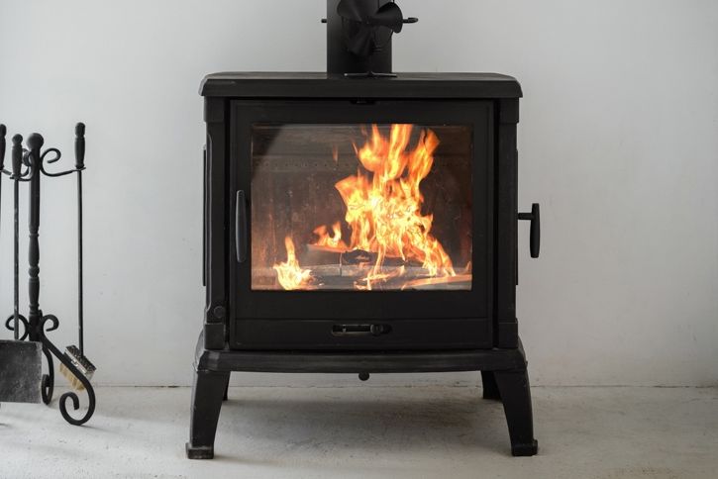
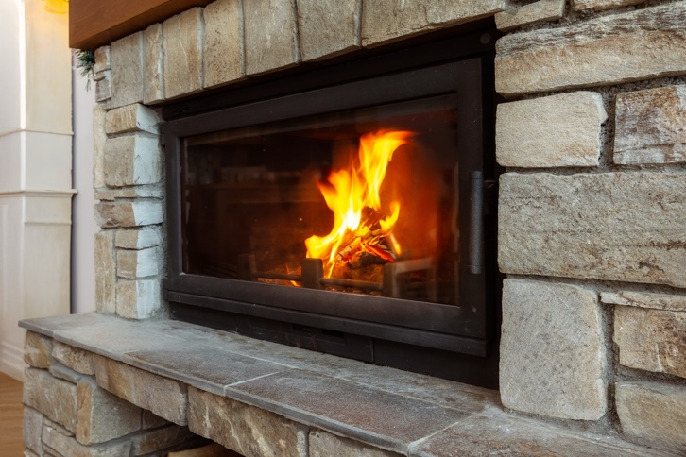
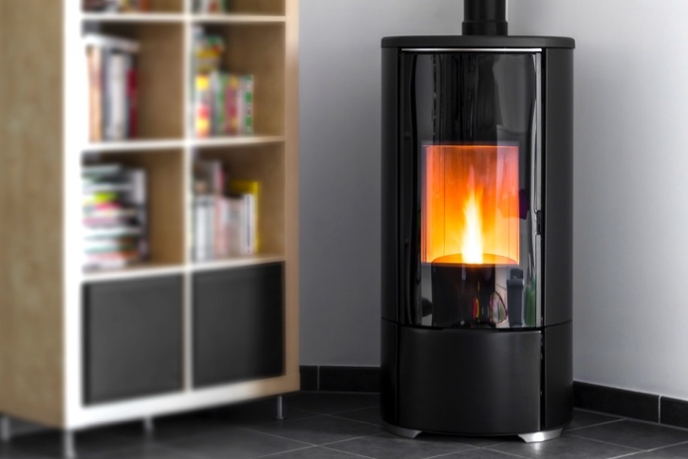
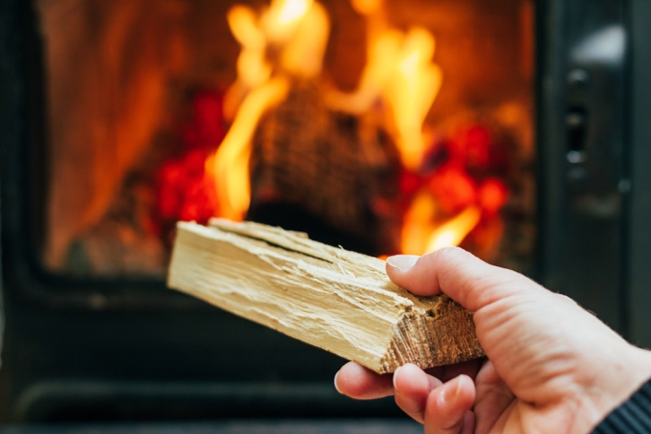

Role of Solid Fuel Heating in Canada

Solid fuel heating plays a vital role across Canada, particularly in rural and semi-rural communities where access to energy infrastructure may be limited, and heating costs are higher. Solid fuel appliances provide backup and supplementary heating – they can complement heat pumps, for example. Wood and pellet fuels are often locally sourced and relatively affordable, contributing to household energy security and cost stability. In many regions, solid fuel appliances also serve as critical backup heat sources during power outages and emergencies, providing resilience in the face of extreme weather and grid disruptions. Additionally, using solid fuel heating during peak winter energy demand can help reduce pressure on local electricity and natural gas distribution systems, supporting energy providers by offsetting peak loads and improving overall grid reliability.

The solid fuel heating sector contributes to local and regional economies through job creation and the sustained operation of retail and service networks. Manufacturers, fuel suppliers, installation professionals, and maintenance services support employment while helping to keep energy-related spending within local communities.

In recent decades, the solid fuel heating industry has undergone significant technological advances. Modern combustion systems and emission-control technologies have substantially improved appliance performance. Enhanced testing and certification requirements ensure that new appliances meet strict standards for efficiency, safety, and emissions. Ongoing innovation continues to deliver improvements in fuel efficiency, operational reliability, and environmental performance.

Alignment with Environmental and Air Quality Goals

The industry is increasingly aligned with environmental and air quality objectives. Manufacturers and distributors continue to invest in cleaner technologies and support government performance standards, including EPA and CSA certification requirements. Industry stakeholders also participate in education and outreach efforts focused on proper installation, correct operation, and improved fuel quality, recognizing that informed use is essential to achieving emissions reductions and maintaining air quality benefits.

Practical Policy Options for Air Quality Improvement

Air quality issues are primarily tied to inefficient, older appliances and improper operation (such as using poor fuel, overloading the firebox, or incorrect venting). Municipalities can address these issues in partnership with industry.

Three-Pillar Plan

We propose a three-pillar plan for municipal and regional governments, hoping to address air quality issues.

- Appliance changeout programs

New, certified appliances achieve significantly lower PM2.5 and visible smoke. When governments offer adequate incentives that motivate residents to replace their older uncertified appliances with modern, cleaner units, the results are significant.

Air quality improvements associated with appliance changeout programs can be readily tracked and monitored locally to ensure program benefits.

- Clear standards

When municipal or regional governments act alone to regulate, or even ban, solid-fuel heating, a patchwork of regulations results. This patchwork negatively impacts not only the Canadian wood heating industry (manufacturers, distributors, retailers, and service companies) but also adds confusion to the marketplace. Residents of one municipality may believe they can or cannot use a specific appliance at a particular time of year based on what a neighbouring municipality has done.

Aligning with neighbouring municipalities is crucial to ensuring public safety, education, and improved air quality. Ensuring that any proposed efforts are clear to consumers and informed by industry is also critical.

- Consumer Education and Engagement

Proper operation, fuel use, and maintenance can dramatically reduce emissions. Providing industry-backed best practices (included later in this document) and manufacturer guidance on operating new technologies is crucial to the success of efforts to improve air quality. Following these best practices also benefits consumers and users directly but improving safety, affordability, and reliability.

Addressing Local Issues

Below, we outline some common issues contributing to poor air quality and our suggestions for addressing them in partnership with industry.

Issue | Goal | Suggestions
Residents using uncertified appliances are creating smoke, sometimes leading to neighbourhood complaints. | Transition those households  to modern, cleaner  appliances. | Implement a Solid Fuel Appliance Changeout Program. This program can be targeted to address specific residents or made broadly available.
Residents who do not  heat properly | Educate and encourage  residents to follow best practices for solid fuel heating. | Industry experts are the best educators when it comes to best practices.  Workshops hosted by local industry members can be practical at the grassroots level. Events are typically  sponsored by local businesses and brought together thanks to significant in-kind contributions, meaning limited or no cost to the local government. Providing better access to  properly seasoned fuel will also support and encourage best practices.
Limited access to  proper fuel | Support residents who rely on solid fuel heating by improving access to proper fuel. | Local industry can partner with municipalities to create or ensure access to dry, seasoned wood so that  residents have access to adequate fuel. Better access to appropriate fuel  will decrease the likelihood  that residents will use wet  wood or garbage.

Incentivizing Appliance Changeouts

Appliance changeout programs have consistently proven to be one of the most effective strategies for achieving rapid reductions in particulate matter (PM) emissions. By incentivizing the replacement of older, uncertified appliances with cleaner, certified alternatives, municipalities can realize measurable air quality improvements in a relatively short timeframe.

Program Objectives and Co-Benefits

A coordinated approach to changeout programming would deliver multiple benefits. Such an initiative would improve local and regional air quality, reduce harmful emissions, and support Canadian manufacturers, distributors, and retailers of high-efficiency heating appliances. Additionally, changeout programs offer a valuable opportunity for public education on the safe, efficient, and responsible use of residential wood heating.
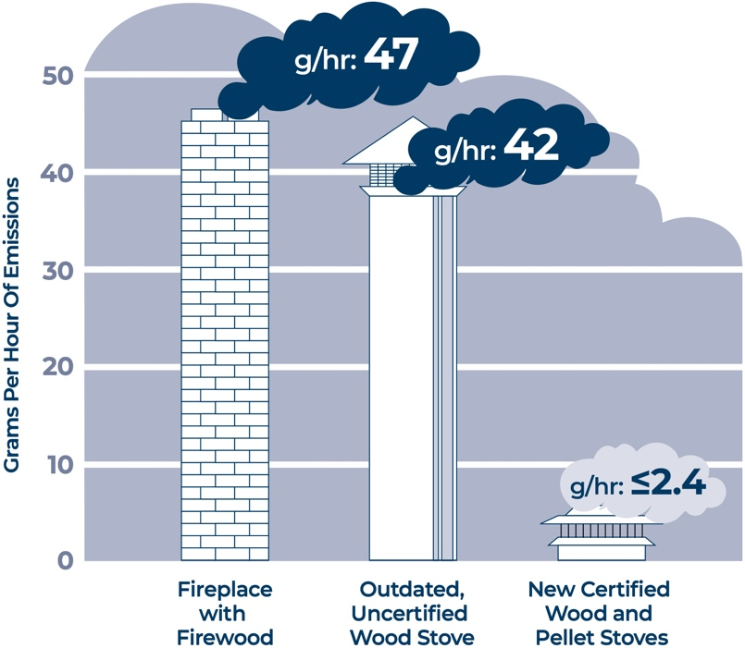

Alignment with Climate and Energy Priorities

Appliance changeout initiatives align closely with priorities (at all levels of government) related to climate resilience, emissions reduction, and energy efficiency, while also respecting consumer choice and the need for reliable home heating. As Canadians face increasing climate variability and extreme weather events, access to dependable backup heating options remains a critical consideration.

Heating Reliability and Public Support

Findings from HPBAC’s The Essential Element, a national survey conducted with thousands of participants across Canada, underscore the importance of heating reliability and consumer choice. The survey found that 97 percent of Canadians believe they should be permitted to use gas and wood appliances as backup heat sources. More than 75 percent of respondents identified consumer choice as a priority in home heating decisions, and over half supported increased government investment in appliance changeout programs to modernize residential heating systems.

Affordability and Energy Security Considerations

Affordability remains a key priority for Canadians, and their energy and heating costs are critical to them. With cost pressures and system challenges persisting, Canadians must have access to heating options that are clean, efficient, and reliable. Well-designed changeout programs help address these challenges by lowering emissions while maintaining dependable home heating and supporting long-term energy security.

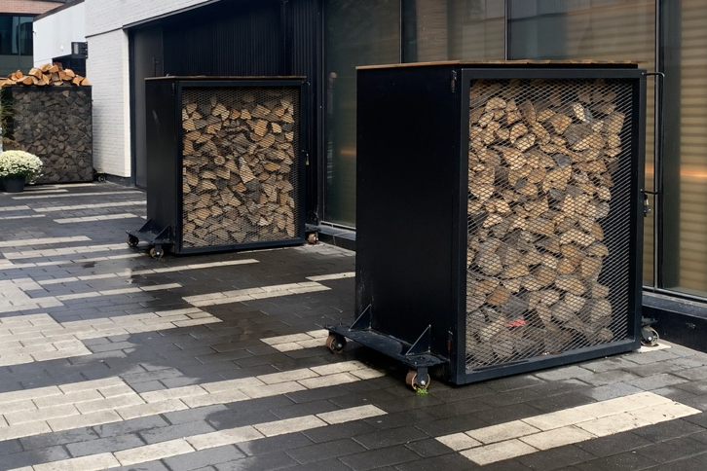
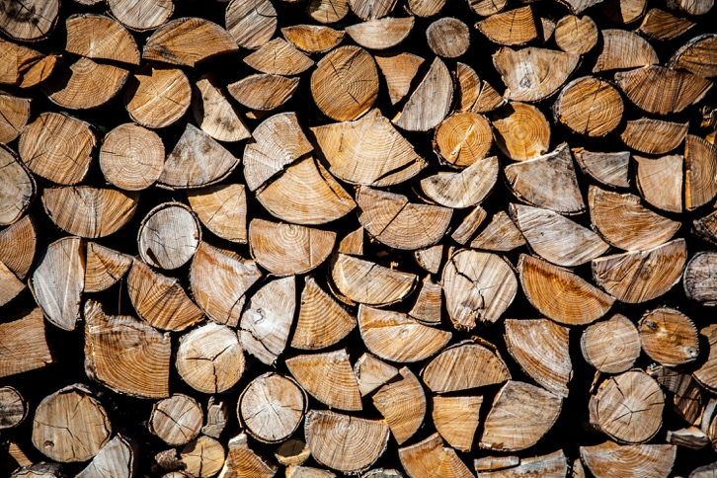

Incentive Design and Eligibility

Effective incentive structures are a core component of successful changeout programs. Incentives should be tied to the verified decommissioning and removal of older appliances, as well as the installation of approved, EPA-certified, and CSA-compliant replacement units.

Depending on the type of appliance, installation costs can vary. Switching from an older freestanding wood stove to a new certified unit will be more straightforward and therefore more affordable than switching to a new built-in fireplace or adding an insert to a masonry chimney, though these are all popular choices and need to be considered.

Incentives should reflect a meaningful percentage of the cost of a new unit, installation, and venting. Meaningful incentive levels are critical to motivating changeouts. We suggest a minimum incentive of $2,000 for installing a new certified unit, which can be applied toward the appliance, venting, and installation costs. Changeout programs can also be designed to prioritize or enhance support for lower-income households, ensuring equitable access to cleaner heating technologies.

Program Pacing, Timing, and Targeting

Program structure and timing play an important role in participation and effectiveness. Multi-year changeout initiatives allow households to plan financially and make informed decisions about appliance upgrades. Targeting priority zones such as areas with higher population density or persistent air quality challenges can further enhance program outcomes and maximize emissions reductions.

Community and Industry Partnerships

Strong partnerships with community stakeholders and industry are critical to successful implementation. Local dealers and certified installers help ensure that appliances are correctly sized, installed safely, and comply with applicable codes and standards. Municipal branding, outreach, and coordinated communication efforts can further build public awareness, trust, and participation.

Funding Opportunities and Cost-Sharing

Changeout programs can be supported through a combination of funding sources, including federal and provincial environmental programs, municipal climate or resilience allocations, and industry cost-sharing arrangements. Leveraging multiple funding streams can improve program stability and reach.

Measuring Success and Program Outcomes

Clear success metrics enable municipalities to track progress and demonstrate results. Standard measures include the number of appliances replaced, estimated reductions in PM emissions, and impacts on household energy costs and consumer satisfaction.

Case Examples and Proven Effectiveness

There have been successful municipal and regional changeout initiatives.

City of Ottawa

HPBAC successfully implemented a program in partnership with the City of Ottawa. The program issued rebates for replacing old, uncertified wood stoves or open fireplaces, representing a significant step toward reducing wood smoke and improving air quality in the City of Ottawa. The program was fully subscribed. Part of the program included public workshops on residential wood heating that covered best practices for residents unable to replace their older units, as well as related health and safety topics.

Québec City

Another great recent example is Québec City’s efforts to incentivize appliance changeouts. The city provided $1.7 million in funding and has replaced nearly 2,000 units, representing a significant impact on air quality and a meaningful improvement.

British Columbia

BC’s Community Wood Smoke Reduction Program incentivizes homeowners to replace older wood appliances with cleaner heating options. It has been adopted in different ways by several municipalities across the province.

Canada’s hearth industry stakeholders support efforts to reduce wood smoke emissions, but feel municipalities using the program should include equal incentives for switching to modern, highly efficient wood appliances. Without that balance, local programs risk steering people disproportionately toward electric heat pumps, rather than recognizing the emissions improvements and continued role of newer certified wood technologies. Consumers should still have a choice for heating solutions.

Public Education

Education can produce immediate air-quality improvements, even without equipment changes, with industry partners playing a crucial role as educators, reinforcing standards at the point of sale.

HPBAC sees immense benefits for public education on solid fuel standards, including higher compliance with local bylaws, community ownership of air-quality improvements, and cost savings and increased home heating efficiency.

Public education programs undertaken by municipalities can be done easily and cost-effectively. Some suggestions for programs which our industry could support or advise on include:

- Moisture meters made available in public libraries or tool libraries
- Demonstrations on proper ignition, loading, and operation of appliances.
- Guides on how to properly store firewood, including instructions on how to build storage
- Distribution of kiln-dried kindling.

HPBAC has prepared industry-informed best practices for wood heating, included below, that could be a valuable resource for public education efforts, benefiting both industry professionals and municipalities.

Use a specialty retailer and a qualified installer.
There are countless choices in size, style, and budget, and specialty retailers can advise on the right option for your home. A professional installation will meet the manufacturer’s instructions, building codes, CSA standards, and local bylaws.
Choose the right appliance size.
A properly sized unit will operate efficiently and safely.
Follow the manufacturer’s instructions.
Different appliances have different requirements, so it is important to consult the owner’s manual. Proper operation and maintenance ensure safety and performance. Some best practices that apply to all wood heating appliances:
Maintain clearances
Ensure adequate air supply and ventilation
Regular inspection and maintenance by a certified chimney sweep
Use proper ignition techniques
Follow correct loading practices
Use the correct fuel.
- Use only the fuels recommended by the manufacturer:
  - Seasoned, dry firewood for wood appliances
  - Certified pellets for pellet appliances
Never burn treated wood or household waste.
Store fuel properly.
- Store firewood split, well-ventilated, and covered on top outdoors; seasoning time varies by species.
- Store pellets in a clean, dry place.
Dispose of ashes safely.
Place ashes in a metal container with a tight lid and store outdoors on a non-combustible surface. Ashes can stay hot for days.
Stay informed and prepared.
Review your manual, keep maintenance records, and contact a professional if you notice performance changes.
For more tips and information:
Consult the HPBAC website at hpbacanada.org or by scanning the QR code.
For a list of specialty retailers, visit www.hpbac.org/find-a-member.

These best practices are also available for download on the HPBAC website.

Industry Partnership – How We Can Help

As the national industry association for the hearth and barbecue industries in Canada, including the solid-fuel industry, HPBAC sees an opportunity to partner with governments and municipalities to reinforce standards and compliance for the use of solid-fuel heating, and to provide input on future programs and policies.

HPBAC can be a key partner to municipalities, including participating in municipal advisory committees or consultations, assisting in the interpretation of local air-quality data and identifying targeted solutions, and maintaining open communication as technologies, standards, and community needs evolve. In addition to participating in government consultations, HPBAC aims to foster greater government engagement by establishing itself as a trusted partner.

HPBAC regularly monitors and provides technical support to members to ensure that the industry continues to comply and adapt to upcoming changes in standards. With this experience, HPBAC and its members possess the expertise to support municipalities and government in formulating policies and programs related to the solid-fuel industry and standards. This expertise includes providing guidance on codes, certification standards, and appliance performance, reviewing proposed bylaws for practicality, safety, and alignment with national standards, and sharing data and research on emission reductions from different policy approaches.

HPBAC has been working to propose policies and formulate programs that better align the solid-fuel industry with existing and upcoming government priorities and sees an opportunity to expand these efforts by working with governments and municipalities. Regarding the proposed Change-Out Program, HPBAC would be open and enthusiastic about working directly with municipalities to assist in designing incentive programs, including eligibility criteria and verification processes. This would involve coordinating participation from local dealers and installers to ensure proper sizing and safe installation, and providing communications support to increase program uptake.

HPBAC aims to partner with governments to collaborate on public education efforts related to policies and programs that will impact members and the broader public. HPBAC would support the government in co-developing clear, consistent messaging on proper operation, fuel quality, and maintenance, and in equipping municipalities with ready-to-use materials, workshops, and dealer-led education opportunities.

HPBAC and the solid-fuel heating industry are committed to working collaboratively with municipalities to improve air quality while maintaining safe, affordable home heating options.
We are ready to be a trusted partner in delivering solutions that meaningfully reduce emissions and support residents.

For more information:

Mike McNeice
Director of Public Affairs
mike@hpbacanada.org

Zahra Khan
Public Affairs and Communications Specialist
zahra@hpbacanada.org

Hearth, Patio & Barbecue Association of Canada 2026

